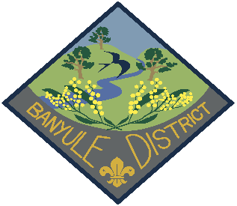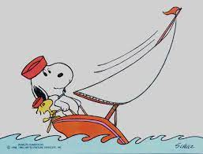

Banyule Cubs End of Year Activity
Try Sailing Day at the Scouts/Guides Sailing Centre
40a Jetty Rd.
Sandringham
Date: Saturday 11th November 2023
Cost $35 per Cub
Payment details are:
Banyule District Cub Scouts
BSB 633 000
A/C 152262291
For the reference please use:
” November Sailing Day” with the Cubs name & Group.
For example: Mabel Jones Watsonia Cubs
RVSP: Friday 3rd November via your Akela
An Operoo profile will be set up for the event
## For catering purposes:
A water bottle is a must.
We are supplying lunch ( BBQ sausages in bread ) along with snacks & fruit
Require numbers for both Cubs & Adults
Please advise any dietary requirements
What to bring:
Please label all gear with your name & Group:
- Cub Scout uniform & Scarf or Group Polo top
- Rashie or swim top
- Covered shoes that can be worn in water.
- Sunscreen
- Hat
- Plastic bag to put wet clothes in
- Plastic bag to keep your clothes & shoes in so that they can go home dry.
- Towel
- Water bottle
- Pair of shoes/runners to go home in.
- 1 pair spare socks
- Change of undies

Pre-requisites: All participants must be able to swim 50 meters unassisted.
Adults (Leader & /or Adult Helper) must hold Certificate of Adult Membership in Scouting & current WWC.
Youth Members must be members of Scouting, & require an Adult Leader in attendance who remains the Leader in Charge for those youth.
## Pete to provide wrist bands – Green competent swimmers & Blue for those to keep an eye out for#
Activity Location:
Scout Water Activity Centre
40a Jetty rd.
Sandringham
Time Overview:
Start time 9.30 am, on water activities start from 10.00 am
11.00 am Remembrance Day – Minute’s Silence/Moment of Reflection
Lunch 12pm to 1 pm
End 3.30 pm
Getting to the event and home.
Saturday 11th November 2023
Using the Hurstbridge line timetable
Leave Rosanna Station at 8:18am
### Would use the rear carriage of the train as the meeting point ###
Change at Flinders st Station from platform 1 to Platform 13 Sandringham line.
This is up one set of stairs walk 50 meters and then down onto Platform 13.
Will set up Leaders to act as “guides” to ensure that Cubs go in the direction we would like them to and to the appropriate platform.
Arrive Sandringham 9.27
Require Myki card applicable for Zones 1 & 2.

Travel from Sandringham Station to the Scout/Guide Water Activities Centre
When leaving the station walk along Melrose Street to the crossing lights at Beach Road and join up with the Bay Trail, wait in the small park there until we can walk together.
Walk along the Bay trail until we get to Jetty Road look out for the Sandy Beach HQ Kiosk next to Trey Bit reserve.
200 meters past this is the Guide Scout Water Activities Centre
10 minute’s walks to the Activity Centre.
Depart Sandringham on the 3.57 and arrive at Rosanna 5:17pm
Yours In Scouting
Jan Bryar & Pete Owens
DLCS Banyule
Mb 0408 323 083
Em: peter_d_owens@bigpond.com

